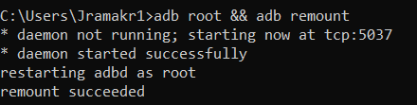
- adb install com-chartcross-gpstest-58-64862170-3b758487ba5190211b34a663d9058288.apk

- Ensure 3d fix is seen on GPS TEST application
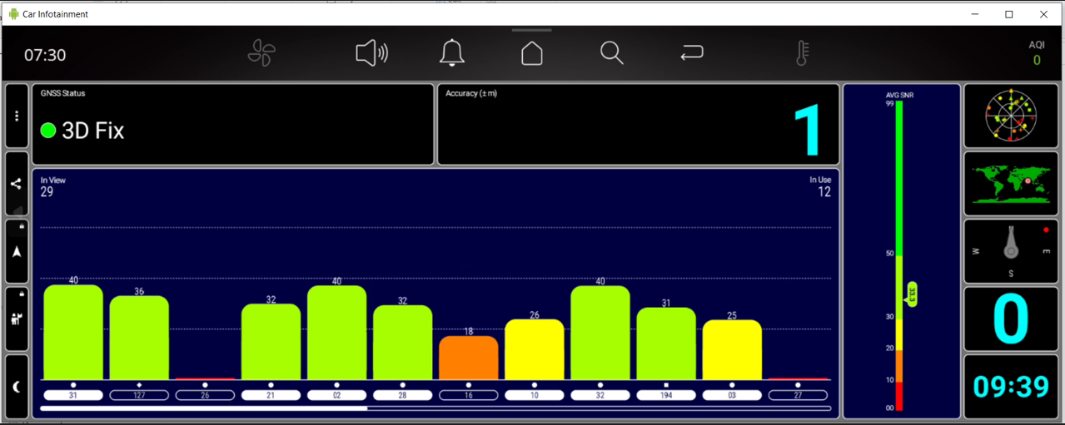
- adb shell
- adb pull /vendor/etc/adr/adr.conf
- edit the pulled adr.conf in notepad++
- replace line number 91 open_data_store=0 by open_data_store=1
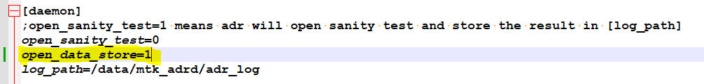
- adb push adr.conf /vendor/etc/adr/adr.conf
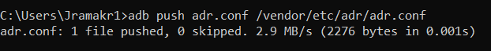
- Clear all vstlog and mtk_adrd (cd /data, rm -rf mtk_adrd and cd /data, rm -rf vstgloballogcontrol)
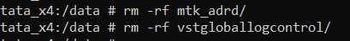
- do battery cycle
- Start the vehicle and leave for 5 mins
- adb shell
- cd /data/mtk_adrd/adr_log/
- cat …MEMS logs
- Ensure
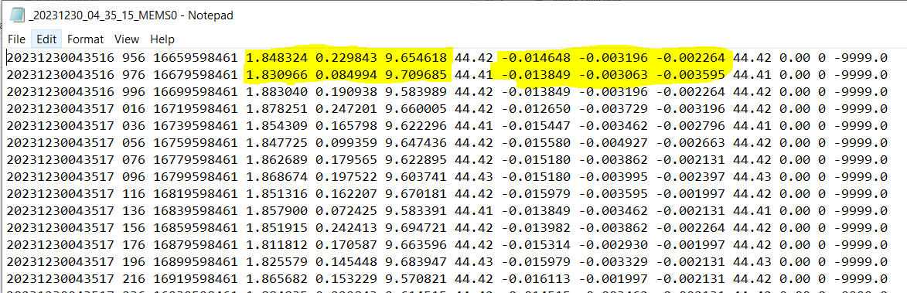
- collect the logs
- exit from adb shell…
- adb pull /data/mtk_adrd – rename this folder to gyro_data_collection_location_5mins_logs
Location—Bangalore/Mumbai/Chennai
- turn ignition off and leave for 15 mins.
- After 15 mins, turn ignition on. Let the vehicle be on for 30 mins.
- adb pull /data/mtk_adrd – rename this folder to gyro_data_collection_location_5mins_logs
- collect the logs and share both the files with timestamps

